**Exercise 3**

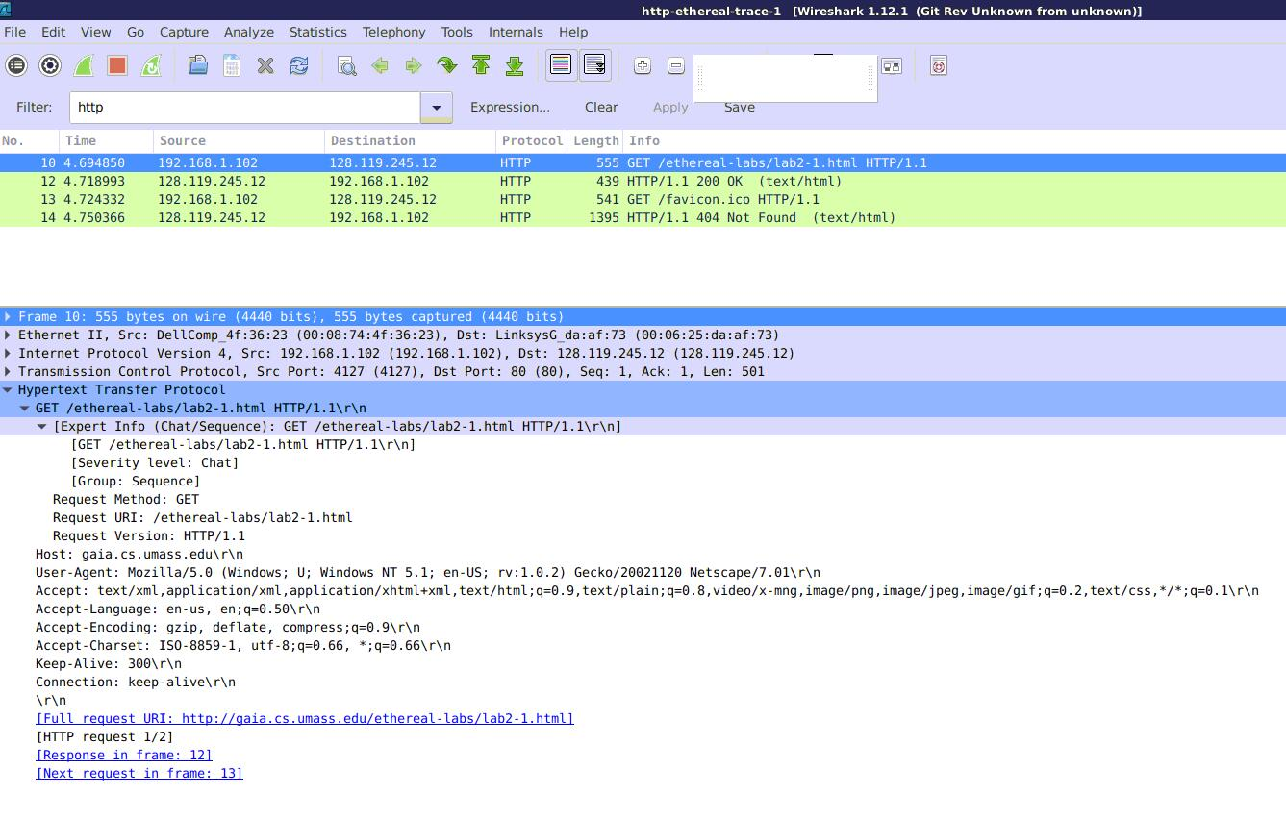

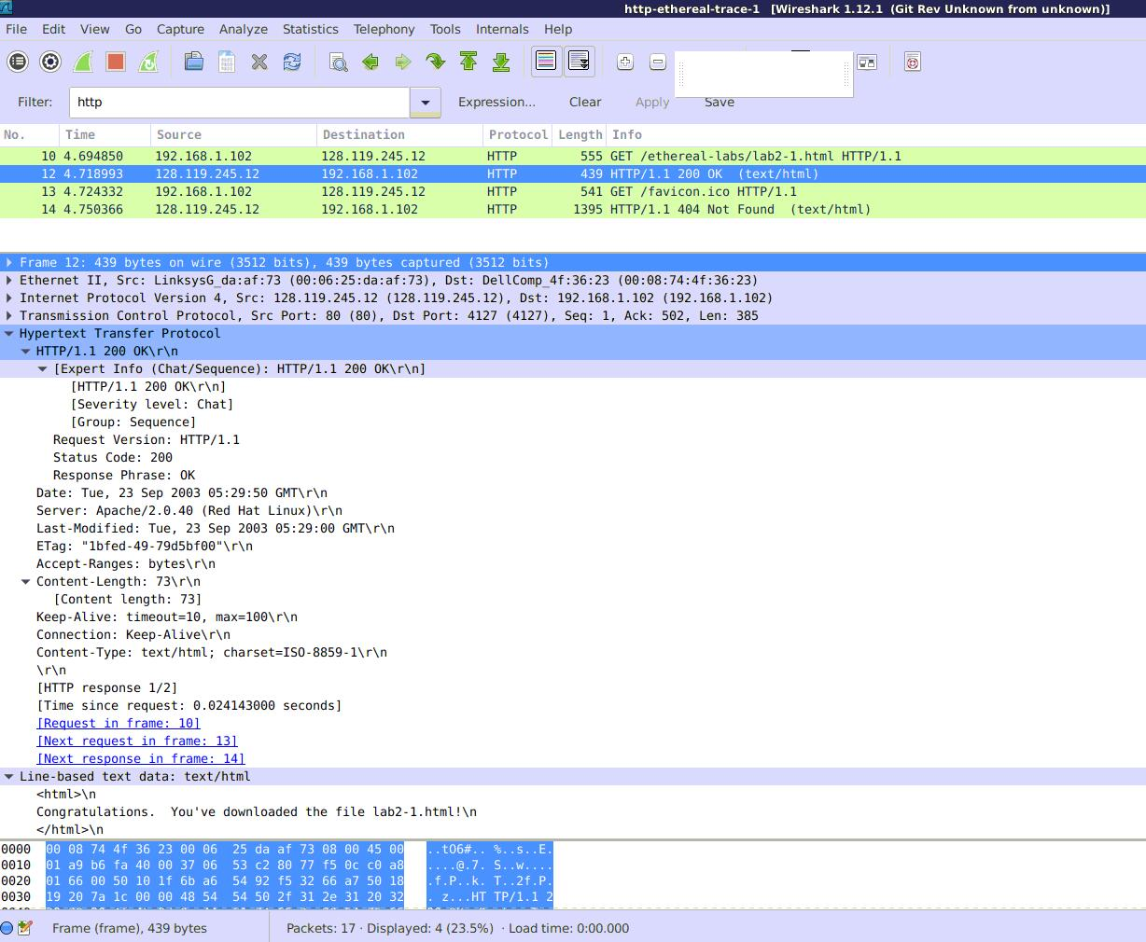

Question 1:

Status code: 200

Phrase: OK

Question 2:

Last –Modified: Tue, 23 Sep 2003 05:29:00 GMT

Yes. Date: Tue, 23 Sep 2003 05:29:50 GMT

The DATE header refers to the date and time when the server retrieved the object and inserted the object found into response message, then sent the message to client. While the Last –Modified date means the time and date when object was created or last –modified.

Question 3:

It is persistent connection.

‘Connection: keep –alive’.



Question 4:

73 bytes.

Question 5:

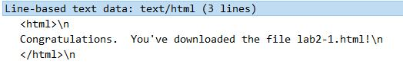

**Exercise 4**

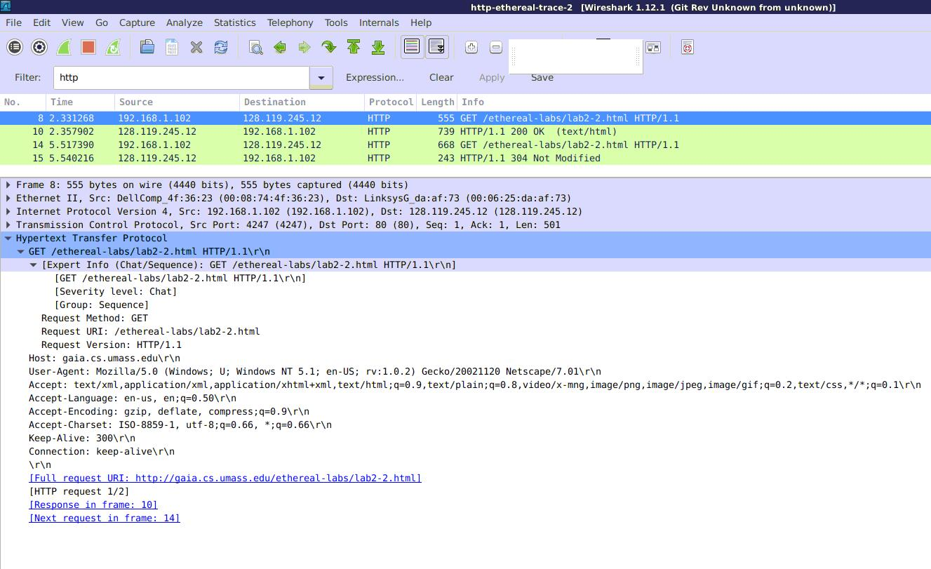

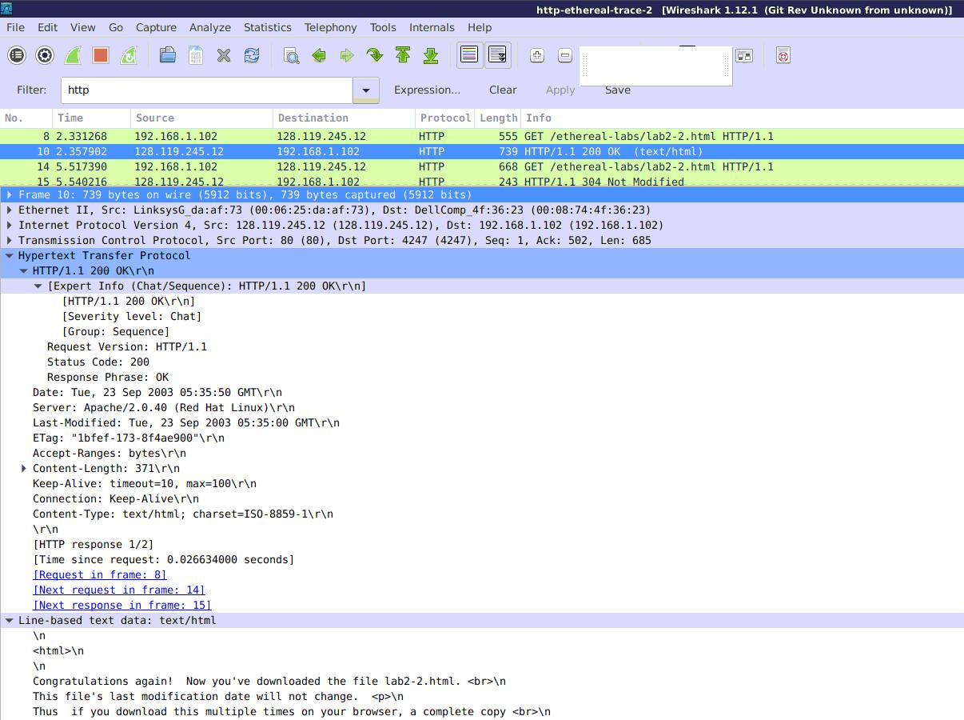

Question 1:

No.

Question 2:

Yes. Last –Modified : Tue, 23 Sep 2003 05:35:00 GMT

Question 3

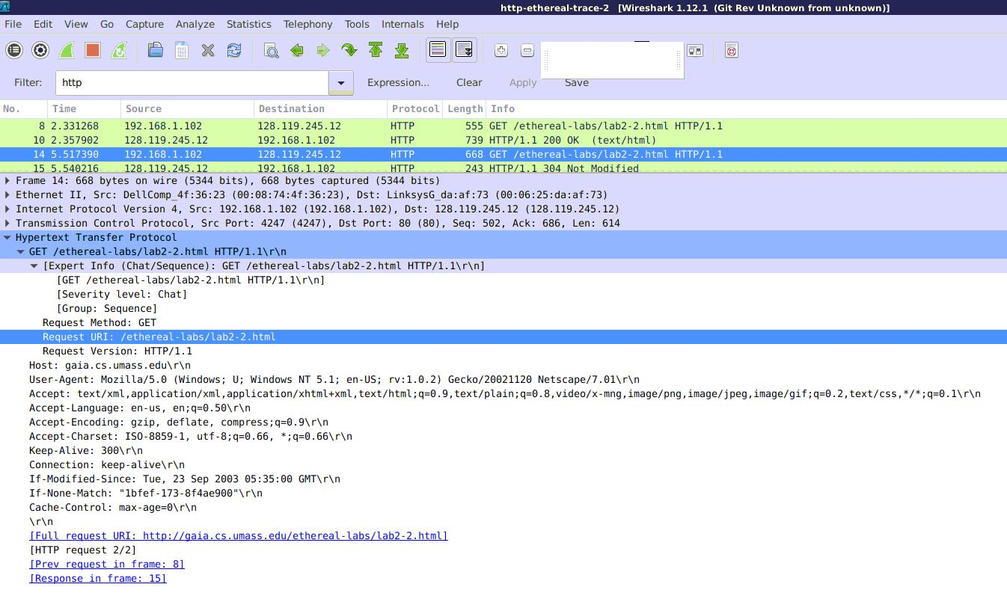

Yes.



Question 4:

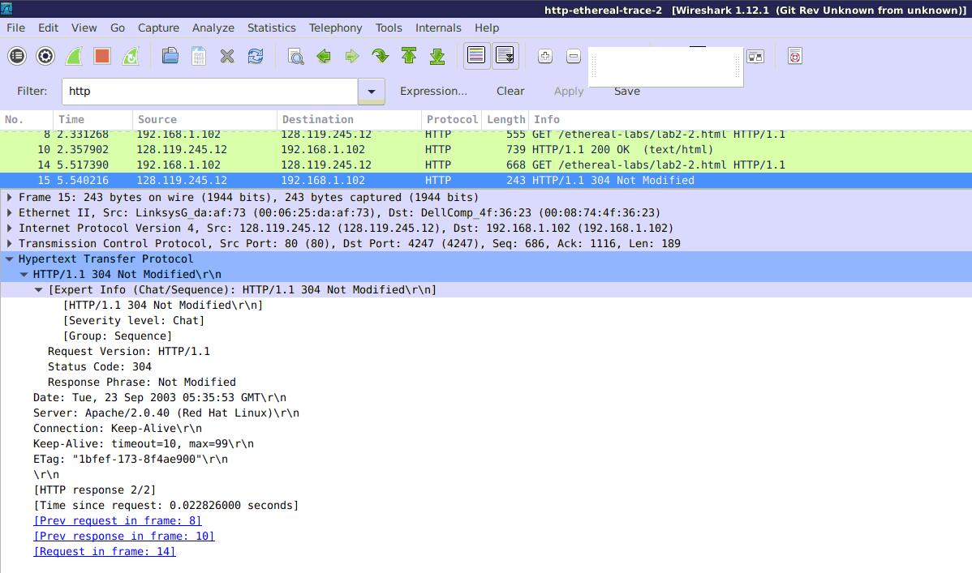

Status code: 304

Phrase: Not Modified

The contents of the file was not returned explicitly. Because the request message is in conditional GET method. The contents had been saved in Web cache before. 304 Not Modified means the object was not modified, thus the object saved in cache could be used, and the object would not be sent again in this respond message.

Question 5:

ETag: "1bfef-173-8f4ae900".

It is a ‘sign’ of an object in server. The server could judge whether the object is modified by using the ETag value. If not modified (then its ETag would not change), returns 304 HTTP status code.

The value didn’t change.

**Exercise 5**

File *‘PingClient.py’* has been attached.

